**MINISTRY OF EDUCATION AND TRAINING**

**FPT UNIVERSITY**

Capstone Project Document

**Health Support Tracking System**

|  |  |
| --- | --- |
| **Group 3** | |
| **Group members** | Ha Kim Quy – QuyHKSE61160  Tran Dang Quan – QuanTDSE60878  Man Huynh Khuong - KhuongMHSE61148  Phan Nhat Anh – AnhPNSE90158 (Dropped out)  Nguyen Duy Khuong – Khuongnd60493 (Dropped out) |
| **Supervisor** | Mr. Kieu Trong Khanh |
| **Ext. Supervisor** | N/A |
| **Capstone Project code** | HSTS |

-Ho Chi Minh City, 09/09/2015-

# Table of Contents

Table of Contents 3

List of Tables 5

List of Figure 8

Definitions, Acronyms, and Abbreviations 11

A. Project Management Plan 12

1. Problem Definition 12

1.1. Name of this Capstone Project 12

1.2. Problem Abstract 12

1.3. Project Overview 12

2. Project organization 15

2.1. Software Process Model 15

2.2. Roles and responsibility 15

2.3. Tools and Techniques 16

3. Project Management Plan 17

Software development life cycle 17

B. Software Requirement Specification 18

1. User Requirement Specification 18

1.1. Doctor Requirement 18

1.2. Doctor Manager Requirement 18

1.3. Nutrition Doctor Requirement 18

1.4. Staff Requirement 18

1.5. Patient Requirement 18

1.6. Admin Requirement 18

1.7. Nurse Requirement 19

1.8. Guest Requirement 19

1.9. Authorized User Requirement 19

1.10. Scheduler Requirement 19

2. System Requirement Specification 20

2.1. Web Application 20

2.2. Mobile Application 21

3. Conceptual Diagram 21

C. Software Design Description 23

1. Design Overview 23

2. `System Architecture Design 23

2.1. Web Application Architecture Description 23

2.2. Mobile Application Architecture Description 24

2.3. Wristband Application Architecture Description 25

3. Component Diagram 25

4. Detailed Description 26

4.1. Class Diagram 26

4.2. Class Diagram Explanation 29

5. Algorithms 35

5.1. Connecting Wristband Algorithm. 35

5.2. Analytic Meal By Voice. 36

5.3. Mail Scheduler Process 37

5.4. Analytic Medical Record Data Process 37

5.5. Analytic Treatment From Server 39

D. Appendix 40

1. SOFTWARE ENGINEERING 9th Edition, by Ian Sommerville. 40

2. Code Conventions for the Java TM Programming Language, by Sun Microsystems, rev April 20, 1999. 40

3. Android Developer Guide - Application Fundamentals - *http://developer.android.com/guide/components/fundamentals.html* 40

4. RFC2532 standard for email validation - *https://html.spec.whatwg.org/multipage/forms.html#valid-e-mail-address* 40

5. Characteristics Standard in BLE - *https://developer.bluetooth.org/gatt/characteristics/Pages/CharacteristicsHome.aspx* 40

6. Way to use Bluetooth Low Energy Standard in Android - *https://developer.android.com/guide/topics/connectivity/bluetooth-le.html* 40

7. Formula to calculate distances, calories based on number steps - *http://www.indiacurry.com/weightloss/walkingrunningcalories.htm* 40

8. Standard Fat Regimen - *http://bacsinoitru.vn/content/benh-beo-phi-1469.html* 40

9. Bảng Thành phần hóa học thức ăn Việt Nam (Viện Dinh Dưỡng Việt Nam) - *http://viendinhduong.vn/home/vi/25/Download.aspx* 40

# List of Tables

Table 1: Definitions, Acronyms, and Abbreviations 7

Table 2: Hardware requirement for continuous integrating server 10

Table 3: Hardware requirement for web development 10

Table 4: Hardware requirement for mobile development 10

Table 5: Hardware requirement for wristband 11

Table 6: Software requirement for this project 11

Table 7: Roles and Responsibility Details 12

Table 8: Tools and Techniques 12

Table 9: Software development lifecycle 13

Table 10: Component Dictionary - Describes components 21

Table 11: Class dictionary: Describe Class 25

Table 12: Class Diagram Explanation - Account 25

Table 13: Class Diagram Explanation - Role 25

Table 14: Class Diagram Explanation - Notify 25

Table 15: Class Diagram Explanation - Doctor 25

Table 16: Class Diagram Explanation - Patient 26

Table 17: Class Diagram Explanation – ParamMearsurement 26

Table 18: Class Diagram Explanation - Appointment 26

Table 19: Class Diagram Explanation - Wristband 26

Table 20: Class Diagram Explanation - Food 27

Table 21: Class Diagram Explanation - FoodIngredient 27

Table 22: Class Diagram Explanation - Illness 27

Table 23: Class Diagram Explanation - MedicalRecord 28

Table 24: Class Diagram Explanation - MedicalRecordData 28

Table 25: Class Diagram Explanation - Medicine 28

Table 26: Class Diagram Explanation - Phase 28

Table 27: Class Diagram Explanation – Practice 28

Table 28: Class Diagram Explanation - PreventCheck 29

Table 29: Class Diagram Explanation - PropertyRecord 29

Table 30: Class Diagram Explanation - Regimen 29

Table 31: Class Diagram Explanation - Role 29

Table 32: Class Diagram Explanation - Treatment 30

Table 33: Class Diagram Explanation - UnitOfFood 30

# List of Figure

Figure 1 Modified Waterfall Development Model 11

Figure 2: System Overview Use Case – Web Application 16

Figure 3: System Overview Use Case – Mobile Application 17

Figure 4: Main Flow 17

Figure 5: Conceptual Diagram 18

Figure 6: System Architecture Design 19

Figure 7: Component Diagram 21

Figure 8: Class Diagram 23

Figure 9: Algorithms – Connecting Wristband Algorithm - Flow Chart 31

Figure 10: Algorithms - Analytic Meal By Voice - Flow Chart 32

Figure 11: Algorithms - Mail Scheduler Process - Flow Chart 33

Figure 12: Algorithms - Analytic Medical Record Data Process - Flow Chart 34

Figure 13: Algorithms - Analytic Treatment From Server - Flow Chart 35

# Definitions, Acronyms, and Abbreviations

|  |  |  |
| --- | --- | --- |
| **No.** | **Abbreviation & Acronym** | **Definition** |
| 1 | BLE | Bluetooth Low Energy |
| 2 | HSTS | Health Support Tracking System |

*Table 1: Definitions, Acronyms, and Abbreviations*

# Project Management Plan

## Problem Definition

### Name of this Capstone Project

Heal Support Tracking System (HSTS).

### Problem Abstract

At the moment, there is no system which can connect between doctor and patient effectively in Vietnam. Large hospitals can manage their patient’s profile very good, but they can’t collect and manage all patient’s profile in many difference hospitals. In fact, the doctor in a hospital can’t access patient’s record from different hospitals. This situation makes doctor missing information, and then the effective of treatment is always not best liked people hope.

Besides, they have not provided the doctor a good way to track their patient actively yet. The patients also do treatment following doctor’s guide without necessary supporting. Sometime, they forget to use medicine or miss the appointment and etc. Therefore, the effect of treatment is very low. For a common illness like fat, the treatment require patient having to use medicine and do exercise every day. However, if they do exercise over guideline, they may be cause an unexpected problem when do exercise in high frequency.

For the goal that improving the treatment, we provide a system to make more communication between doctor and patient. By collecting patient’s information every day, the doctor can make the treatment more effectively, for example, the doctor can change the medicine immediately. The patient can save their time because they can receive newest medicine over a message or a notification. The patient also will be remind to meet appointment with doctor, etc.

### Project Overview

#### Current Situation

Below are the problems encountered in this project:

* **Collect requirement**: The medical treatment of a lot of diseases is the privacy asset of hospitals so we are difficult to access these documents.
* **Medical knowledge**: This project requires member have enough medical knowledge about treatments, common diseases and process.
* **Technique**: Some manufacturer do not use standard of Bluetooth developer.
* **Absent of the team member**: team members can get sick or unexpected problems.

#### The Proposed System

According to technology researches, we found out that a wristband with Bluetooth connection can help us resolving the problem of tracking fat patient’s treatment effective. We can use basic feature of a wristband such as measuring distance, calories burned to help doctor tracking the effective of treatment. Then doctor can improve the treatment for patient.

To resolve the medical knowledge problem, we have gone to some large hospitals in Ho Chi Minh City such as Ho Chi Minh Nutrition Center and Traditional Medical Hospital for understanding processes. And then, we have noted the real treatment for the fat. We also find the necessary help to access some medical documents from our friends.

We assign responsibility in vertical to make sure if any members cannot continue to work in our team, there will be the least harmful to the project processes.

Our system include two subsystems:

- An online application for nurse, doctor, nutrition doctor, doctor manager, staff and administrator.

- A mobile application for patient.

##### Mobile Application

This application is used by patient, which is provided features to improve treatment effective. It is included below functions:

* Show treatment which accepted by doctor.
* Remind using medicine, doing exercises, appointment with doctor.
* Collect data from wristband and send to server.

##### Web Application

Main web application is built for a clinic in Vietnam. It models all main processes from a clinic. Below are the detailed features and roles of this web application.

For nurse:

* Register medical examination for patient.
* Print prescription for patient.

For doctor:

* Make prescription.
* View patient medical history.
* View history practice data.

For administrator:

* Manage accounts.

For staff:

* Manage supported devices.
* Update formula to support calculating calories.

For nutrition doctor:

* Make Nutrition Ingredient.
* Manage food’s nutrition.

For doctor manager:

* Manage regimen.

For scheduler:

* Analytic data of wristband.

For analyst:

* Suggest treatment.
* Analytic meal by voice.
* Analytic meal.

#### Boundaries of the System

The system is built basing on real processes of some hospital and medical clinics in Vietnam. Our main target is improving the medical process of treating fat and other common diseases. We recommend that the age limitation of patient is from 20 to 60 years old only.

Especially, this system will not intent to solve below problems:

Firstly, patient’s profile management and missed information among hospitals.

Secondly, any complex diseases that require more human resources or higher technology equipment such as cancer and HIV/AIDS.

#### Development Environment

##### Hardware requirements

* For continuous integrating server:

|  |  |  |
| --- | --- | --- |
| Hardware | Minimum Requirements | Recommended |
| Internet Connection | 512Kbps | 4 Mbps |
| Operating System | Ubuntu Server 12 LTS | Ubuntu Server 14.04.2 LTS |
| Computer Processor | Intel® Pentium II | Intel® Core(TM) i5 CPU , M 460 @ 2.53GHz |
| Computer Memory | 1GB of RAM | 4GB of RAM or more |

*Table 2: Hardware requirement for continuous integrating server*

* For web development:

|  |  |  |
| --- | --- | --- |
| Hardware | Minimum Requirements | Recommended |
| Internet Connection | 512Kbps | 8 Mbps |
| Operating System | Windows Vista, 7, 8 | Windows 7, 8 |
| Computer Processor | 1 GHz | Intel® Core(TM) i5 CPU , M 460 @ 2.53GHz |
| Computer Memory | 2GB of RAM | 4GB of RAM or more |

*Table 3: Hardware requirement for web development*

* For mobile development:

|  |  |  |
| --- | --- | --- |
| Hardware | Minimum Requirements | Recommended |
| Internet Connection | 512Kbps | Wi-Fi Connection 12MB |
| Operating System | Android 4.3 | Android 4.4.2 |
| Hardware | Bluetooth 4.0 | Bluetooth 4.0 |
| Memory | 512 MB of RAM | 1GB of RAM or more |

*Table 4: Hardware requirement for mobile development*

* For wristband – “WRISTBAND TW64”:

|  |  |  |
| --- | --- | --- |
| Hardware | Minimum Requirements | Recommended |
| Bluetooth Connection | BLE Supported | BLE Supported |
| Firmware Revision | 01011206 | 01011206 |
| Hardware | Bluetooth 4.0 | Bluetooth 4.0 |
| Memory | 64KB RAM | 64KB RAM |

*Table 5: Hardware requirement for wristband*

##### Software requirements

.

|  |  |
| --- | --- |
| Tools | Uses |
| MySQL Server 5.6 | Used for creating and manage the database for system. |
| IntelliJ IDEA 14.1.4 | Used for implementing website and web service. |
| Android Studio 1.3.2 | Used for implementing Android mobile |
| Github server | Used for storing source codes, documents. |
| SourceTree 1.6.20 | Used for version control |
| Software Ideas Modeler 8 | Used for creating models and diagrams |

*Table 6: Software requirement for this project*

## Project organization

### Software Process Model

This project is developed under waterfall model. We apply customized waterfall model to capable with current situation in our team. We choose this model because the following reasons:

* This is a project with clear requirement.
* Based on researches and clarify standard regimen of diseases are stable, clear, fixed and well understood by all team members.
* This project use BLE technology, which we have standard in bluetooth developer and android support.

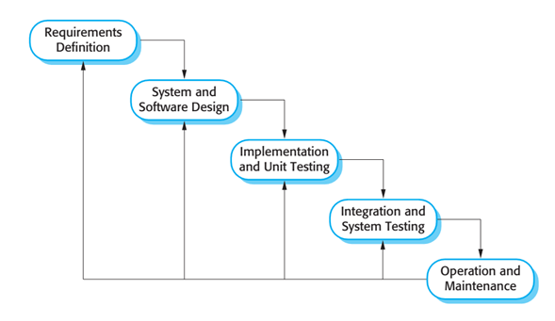

*Figure 1 Modified Waterfall Development Model*

Reference: Page 30, chapter 2, Software process model, SOFTWARE ENGINEERING 9th Edition, by Ian Sommerville

### Roles and responsibility

|  |  |  |  |
| --- | --- | --- | --- |
| **No** | **Full name** | **Role in Group** | **Responsibilities** |
| **1** | Kieu Trong Khanh | Supervisor/Project Manager | * Specify user requirement * Control the development process * Give out technique and business analysis support |
| **2** | Ha Kim Quy | Team leader, BA, DEV, Tester | * Managing process * Clarifying requirements * Prepare documents * GUI Design * Designing database * Coding * Create test plan * Testing |
| **3** | Tran Dang Quan | BA, DEV, Tester | * Clarifying requirements * Prepare documents * GUI Design * Designing database * Coding * Create test plan * Testing |
| **4** | Man Huynh Khuong | BA, DEV, Tester | * Clarifying requirements * Prepare documents * GUI Design * Designing database * Coding * Create test plan * Testing |

*Table 7: Roles and Responsibility Details*

### Tools and Techniques

|  |  |
| --- | --- |
| Tool / Technique | Name / version |
| Frontend | HTML, CSS, JavaScript, jQuery, Bootstrap |
| Backend | JavaEE, Spring, Hibernate |
| Web server | Apache Tomcat 7 |
| Development tool | IntelliJ IDEA 14.1.4 |
| DBMS | MySQL 5.6 |
| Source control | SourceTree 1.6.20 |
| Modeling tool | Software Ideas Modeler |
| Document tool | Microsoft Word 2013 |

*Table 8: Tools and Techniques*

## Project Management Plan

### Software development life cycle

|  |  |  |  |  |  |
| --- | --- | --- | --- | --- | --- |
| **Phase** | **Description** | **Deliverables** | **Resource needed** | **Dependencies and**  **Constrains** | **Risks** |
| **Requirement Analysis** | - Collect requirements from customer.  -Identify and clarify requirements for the system in general. | -Introduction of proposed system.  -Software requirement specification.  -Project Task Plan.  - Prototypes | 20 man- days | N/A | - Missing requirement  - Unclear scope of  project  - Lack of member share  of understand |
| **Design** | - Architecture design for the system  - Detail design using top-down break down  - Choose Architecture style | - Software Design Document  - Base code structure  - Technology notes | 20 man- days | Depend on  “Requirement  Analysis” | - Lack of experience.  - Not fulfil requirement. |
| **Implementation** | - Coding system core functions and other feature with GUI  - Unit test | - Main user’s functions on mobile and website  - Unit test document | 50 man- days | Depend on “Design”. | - Lack of experience and knowledge.  - Human mistake. |
| **Testing** | - Integration test the system  - Alpha test  - Correct bugs  - Beta test  - Acceptance test | - Test document  - Defect log | 20 man- days | Depend on  “Implementation” | - Lack of experience  - Missing test case |
| **Maintenance** | - Deploy on sever and mobile | - Installation guide  - User Manual | 10 man- days | Depend on  “Testing” | - Lack of experience. |

*Table 9: Software development lifecycle*

# Software Requirement Specification

## User Requirement Specification

### Doctor Requirement

Doctor is user who uses service of system. The doctor can use some following functions:

* View patient’s medical history
* Make prescription
* View patient’s history practice data

### Doctor Manager Requirement

Doctor Manager is user who manages regimen of registering medical examination process. The doctor manager can use some following functions:

* Manage regiment
  + Insert regimen.
  + Update regimen.
  + Delete regimen.

### Nutrition Doctor Requirement

Nutrition Doctor is user who manages nutrition of foods. The doctor manager can use some following functions:

* Make Nutrition Ingredient.
* Manage Nutrition Of Foods
* Insert food’s nutrition.
* Update food’s nutrition.
* Delete food’s nutrition.

### Staff Requirement

Staff is user who manages formula to calculate data and data of wristband. The staff can use some following functions:

* Manage formula.
* Manage supported devices
* Insert device
* Delete device
* Update device information

### Patient Requirement

Patient is people who use service of system. The patient can use some following functions:

* Pair wristband.
* Configure Alarm
* Logout

### Admin Requirement

Admin is people who manages account. Administrator can use some following functions:

* Manage account includes:
* Remove account.
* Add account based on template.
* Update specific account.

### Nurse Requirement

Nurse is user who uses service of system. The doctor can use some following functions:

* Register Medical Examination.
* Print prescription.

### Guest Requirement

Guest is user does not login to this system. Guest only has one function.

* Login

### Authorized User Requirement

Authorized User is user who has logged into system. Authorized User only has on function.

* Logout

### Scheduler Requirement

Scheduler is TaskScheduler in system which schedules tasks to run at some points:

* Analytic data of wristband.
* Analytic new treatment for patient in smartphone.
* Remind patient.
* Get data from wristband.
* Synchronize practice data to server.
* Notice practice result to patient.
* Check notifications of patient.

## System Requirement Specification

### Web Application

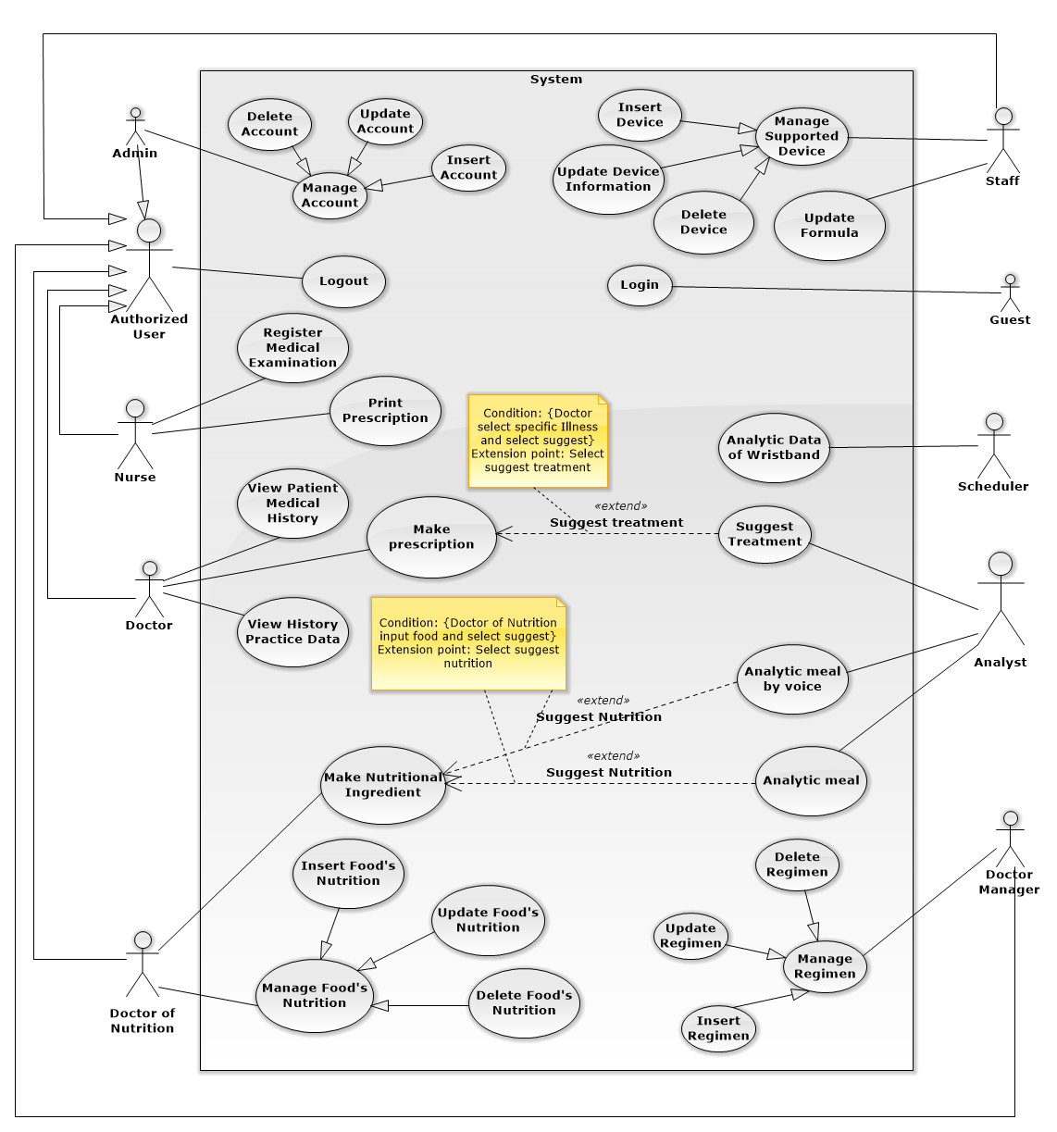

*Figure 2: System Overview Use Case – Web Application*

### Mobile Application

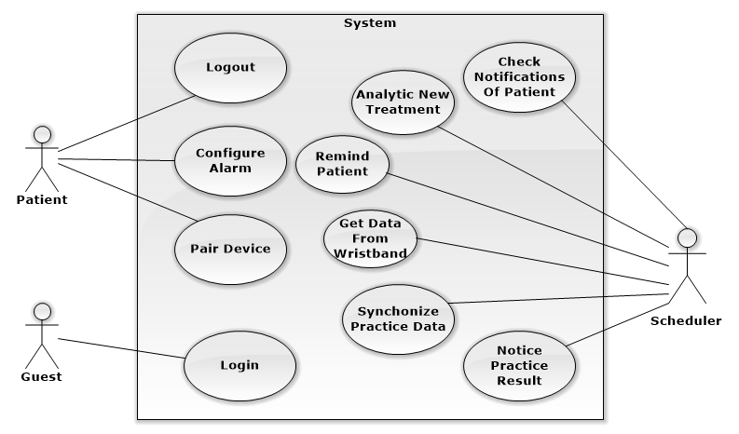

*Figure 3: System Overview Use Case – Mobile Application*

### Main Flow

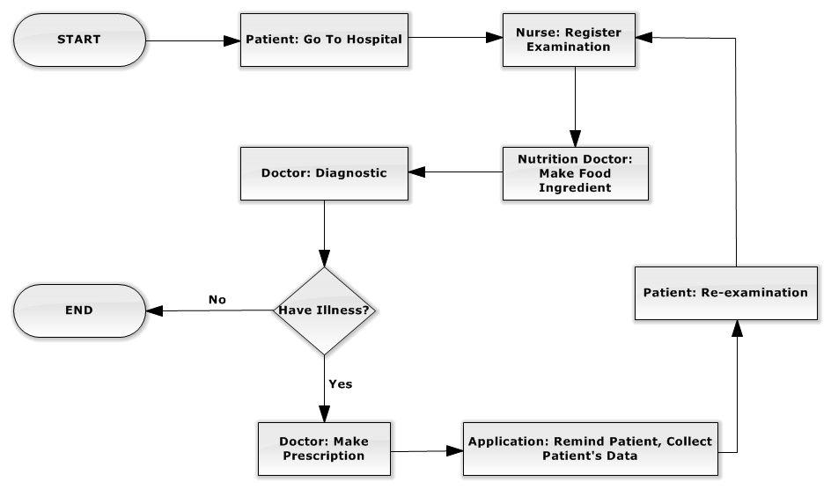

*Figure 4: Main Flow*

## Conceptual Diagram

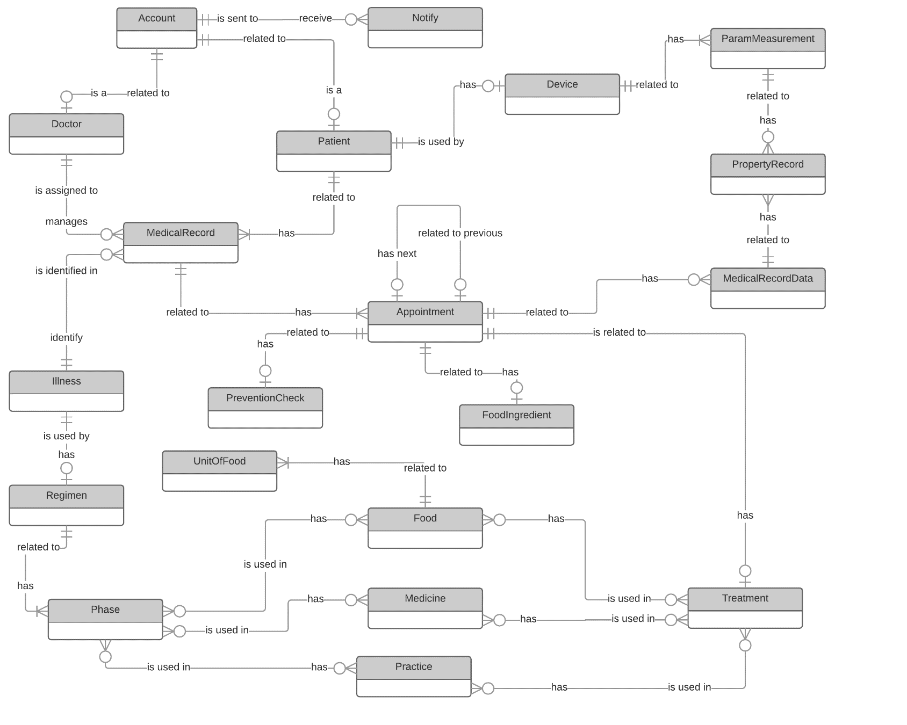

*Figure 5: Conceptual Diagram*

# Software Design Description

## Design Overview

* The architectural design describes the overall architecture of the system and the architecture of each main component and subsystem.
* The detailed design describes static and dynamic structure for each component and functions. It includes class diagrams, class explanations and sequence diagrams for each use cases.
* The database design describes the relationships between entities and details of each entity.
* Document overview:
  + Section 2: gives an overall description of the system architecture design.
  + Section 3: gives component diagrams that describe the connection and integration of the system.
  + Section 4: gives the detail design description, which includes class diagram, class explanation, and sequence diagram to details the application functions.
  + Section 5: describe a fully attributed Entity Relationship Diagram.

## System Architecture Design

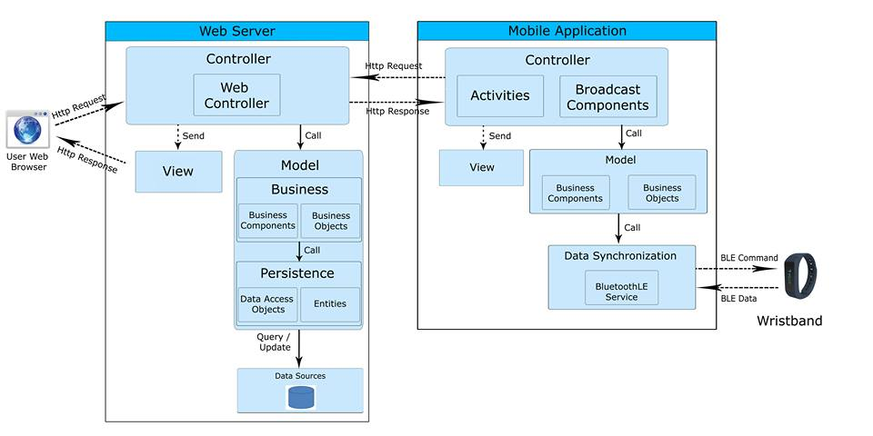

*Figure 6: System Architecture Design*

### Web Application Architecture Description

In Web Application, the system is developed under Spring MVC architecture style. We choose this architecture for Web application because of following advantages:

* Web app contains Web services with MVC architecture, we can separate business code with Controller and View. So we can use the business code in web service without repeat the code.
* We can organize the code better for maintainability, extensibility, reusability so we can expand the scope to other kind of illnesses such as flu, fever…
* In scope of 3-members team, MVC architecture make it easier to split the big project into small modules and make it easier to assign each module for members in our team.

This project follows MVC architecture with following components:

* **Controller** is the parts of the web server that acts like event handler to handles user interaction.
  + - **Web Controller** is the parts of the controller that acts like event handler for web and server communication via HTTP protocol.
* **Model** is the parts of the web server that acts like a data transfer object between the system and database, handle business of system.
  + - **Business** is the parts of the model that do business processing to solve domain problems.
      * **Business Component** is the parts of the business that do business of system.
      * **Business Objects** is the parts of the business that define some objects to use in business component.
    - **Persistence** is the parts of the model that transfer object between the system and database.
      * **Entities** is the parts of persistence that mapping table in database with each object in DAO.
      * **Data Access Object** is the parts of persistence that provides some methods and classes to persistent store data into database.
* **View** is the parts of the web server that acts like event handles the display of the data. The selection of View is under control of Controller.

### Mobile Application Architecture Description

The application is developed as an Android native application. In general, the application architecture conforms to Android architecture.

This project follows Android application architecture with following component:

* **Controller** is the parts of mobile application that handles user input, create thread to run asynchronous tasks and synchronize data, get notify from server
  + - **Activities** is the parts of the controller that handles user input, create thread to run asynchronous tasks, send request and receive data from server via web services,…4
    - **Broadcast Components** is the parts of the controller that tracking notify or new data from server
* **View** is the parts of the web server that acts like event handles the display of the data. The selection of View is under control of Controller.
* **Model** is the parts of the mobile application that do business processing to solve domain problems in mobile application.
  + - **Business Component** is the parts of business layer that do business of mobile application.
    - **Business Object** is the parts of business layer that define some objects like DTO in server and some objects to use in business component.
* **Data Synchronization** is the parts of the mobile application that use to get data from wristband and manage connection with wristband.
  + - **BluetoothLE Service** is the parts of the data synchronization that tracking data from wristband.

### Wristband Application Architecture Description

We only use Bluetooth to get data from wristband, using BLE standard command. So, we don’t need to use application API in wristband or implement it.

## Component Diagram

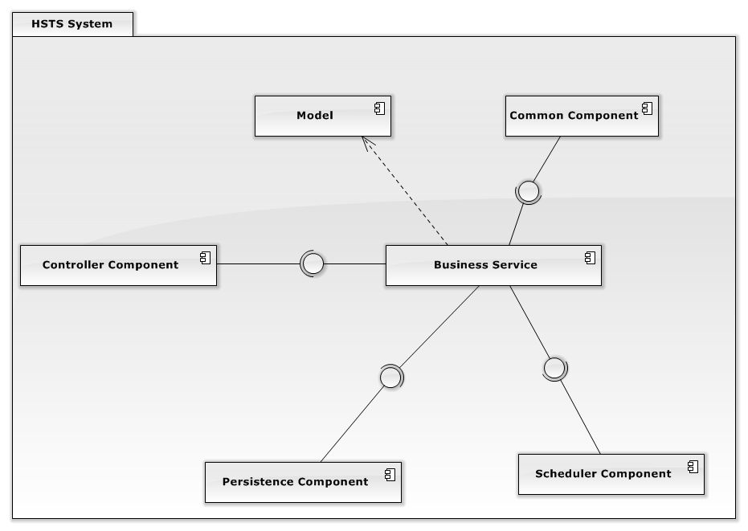

*Figure 7: Component Diagram*

|  |  |  |
| --- | --- | --- |
| Component Dictionary: Describes components | | |
| Controller Component | Component is used to handle request from web. | vn.edu.fpt.hsts.web |
| Persistence Component | Component is used to handle interaction between the system and database. | vn.edu.fpt.hsts.persistence |
| Business Service | Common services are used to handle system’s business operations. | vn.edu.fpt.hsts.bizlogic |
| Model | Common object is used in business service component. | vn.edu.fpt.hsts.bizlogic.model |
| Common Component | Component is used to handle common function in the system. | vn.edu.fpt.hsts.common |
| Scheduler Component | Component is used to handle scheduler in the system | vn.edu.fpt.hsts.scheduler |

*Table 10: Component Dictionary - Describes components*

## Detailed Description

### Class Diagram

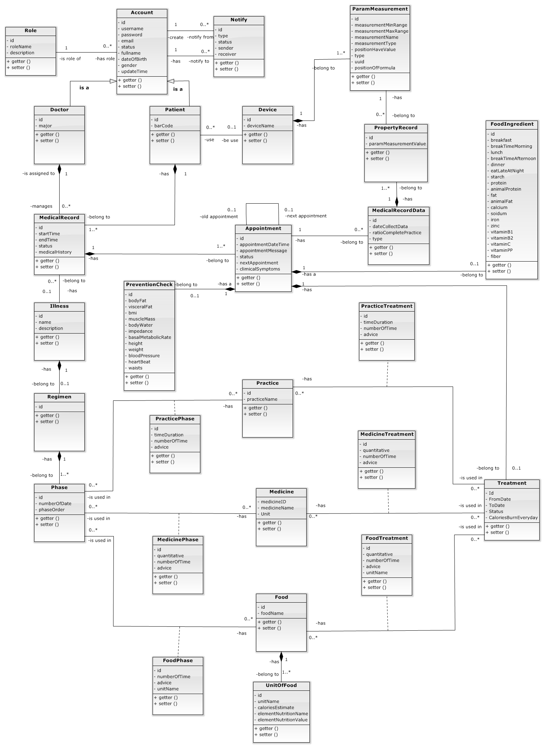

*Figure 8: Class Diagram*

|  |  |  |
| --- | --- | --- |
| Class dictionary: describe Class | | |
| Class Name | **Mapping column with Conceptual diagram** | **Description** |
| Account | Account | Contain the account information. |
| Role | N/A | Not exist in conceptual diagram. But needed in class diagram to contain role information. |
| Notify | Notify | Contain the notify information |
| Doctor | Doctor | Contain the doctor information. |
| Patient | Patient | Contain the patient information. |
| Wristband | Device | Contain the wristband information. |
| ParamMeasurement | ParamMeasurement | Contain the parameter of measurement information. |
| PropertyRecord | PropertyRecord | Contain the property record information. |
| MedicalRecord | MedicalRecord | Contain the medical record information. |
| MedicalRecordData | MedicalRecordData | Contain the medical record data information. |
| Appointment | Appointment | Contain the appointment information. |
| Illness | Illness | Contain the illness information. |
| PreventionCheck | PreventCheck | Contain the prevent check information. |
| FoodIngredient | FoodIngredient | Contain the food ingredient information. |
| Regimen | Regimen | Contain the regimen information. |
| Phase | Phase | Contain the phase information. |
| PracticePhase | N/A | Not exist in conceptual diagram. But needed in class diagram to contain the practice phase information. |
| MedicinePhase | N/A | Not exist in conceptual diagram. But needed in class diagram to contain the medicine phase information. |
| FoodPhase | N/A | Not exist in conceptual diagram. But needed in class diagram to contain the food phase information. |
| Practice | Practice | Contain the practice information. |
| Medicine | Medicine | Contain the medicine information. |
| Food | Food | Contain the food information. |
| PracticeTreatment | N/A | Not exist in conceptual diagram. But needed in class diagram to contain practice treatment information. |
| MedicineTreatment | N/A | Not exist in conceptual diagram. But needed in class diagram to contain medicine treatment information. |
| FoodTreatment | N/A | Not exist in conceptual diagram. But needed in class diagram to contain food treatment information. |
| Treatment | Treatment | Contain the treatment information. |
| UnitOfFood | N/A | Not exist in conceptual diagram. But needed in class diagram to contain the unit of food information. |

*Table 11: Class dictionary: Describe Class*

### Class Diagram Explanation

#### Account

|  |  |  |  |
| --- | --- | --- | --- |
| Attribute | Type | Visibility | Description |
| Id | int | Private | Unique identifier of an account |
| Username | String | Private | The username. |
| Password | String | Private | The password. |
| Email | String | Private | The email of user. |
| FullName | String | Private | The full name of user. |
| Status | int | Private | The status of account. |
| DateOfBirth | Timestamp | Private | The birthday of user. |
| Gender | int | Private | The gender of user. |
| UpdateTime | Timestamp | Private | The day processes updating account. |

*Table 12: Class Diagram Explanation - Account*

#### Role

|  |  |  |  |
| --- | --- | --- | --- |
| Attribute | Type | Visibility | Description |
| Id | int | Private | Unique identifier of a role. |
| RoleName | String | Private | The name of role. |
| Description | String | Private | The description about a role. |

*Table 13: Class Diagram Explanation - Role*

#### Notify

|  |  |  |  |
| --- | --- | --- | --- |
| Attribute | Type | Visibility | Description |
| Id | int | Private | Unique identifier of a role. |
| Type | int | Private | The type of notify. |
| Status | int | Private | The status of notify. |

*Table 14: Class Diagram Explanation - Notify*

#### Doctor

|  |  |  |  |
| --- | --- | --- | --- |
| Attribute | Type | Visibility | Description |
| Id | int | Private | Unique identifier of a doctor. |
| Major | String | Private | The major of doctor. |

*Table 15: Class Diagram Explanation - Doctor*

#### Patient

|  |  |  |  |
| --- | --- | --- | --- |
| Attribute | Type | Visibility | Description |
| Id | int | Private | Unique identifier of a patient. |
| BarCode | String | Private | The barcode of ordinal number. |

*Table 16: Class Diagram Explanation - Patient*

#### ParamMeasurement

|  |  |  |  |
| --- | --- | --- | --- |
| Attribute | Type | Visibility | Description |
| Id | int | Private | Unique identifier of a parameter measurements. |
| MeasurementMinRange | int | Private | The min range of measurement. |
| MeasurementMaxRange | int | Private | The max range of measurement. |
| MeasurementName | String | Private | The name of measurement. |
| MeasurementType | String | Private | The type of measurement. |
| PositionHaveValue | int | Private | The position having value of measurement. |
| Type | int | Private | The type of measurement. |
| Uuid | int | Private | The uuid of measurement. |
| PositionOfFormula | String | Private | The position having formula of measurement. |

*Table 17: Class Diagram Explanation – ParamMearsurement*

#### Appointment

|  |  |  |  |
| --- | --- | --- | --- |
| Attribute | Type | Visibility | Description |
| Id | int | Private | Unique identifier of an appointment. |
| AppointmentDateTime | DateTime | Private | The day have appointment with doctor. |
| Status | Byte | Private | Entry, Finish, Waiting. |
| NextAppointment | int | Private | The next day have appointment. |
| ClinicalSymptoms | String | Private | The clinical symptoms of patient. |

*Table 18: Class Diagram Explanation - Appointment*

#### Wristband

|  |  |  |  |
| --- | --- | --- | --- |
| Attribute | Type | Visibility | Description |
| Id | int | Private | Unique identifier of a wristband. |
| BrandName | String | Private | The name of brand. |

*Table 19: Class Diagram Explanation - Wristband*

#### Food

|  |  |  |  |
| --- | --- | --- | --- |
| Attribute | Type | Visibility | Description |
| Id | int | Private | Unique identifier of a food. |
| FoodName | String | Private | The name of food. |

*Table 20: Class Diagram Explanation - Food*

#### FoodIngredient

|  |  |  |  |
| --- | --- | --- | --- |
| Attribute | Type | Visibility | Description |
| Id | int | Private | Unique identifier of a foodIngredient |
| Breakfast | Float | Private | The value of breakfast. |
| BreakTimeMorning | Float | Private | The value of breakfast. |
| Lunch | Float | Private | The value of lunch. |
| BreakTimeAfternoon | Float | Private | The value of break time afternoon. |
| Dinner | Float | Private | The value of dinner. |
| EatLateAtNight | Float | Private | The value of eat late at night. |
| Starch | Float | Private | The value of starch. |
| Protein | Float | Private | The value of protein. |
| AnimalProtein | Float | Private | The value of animal protein. |
| Fat | Float | Private | The value of fat. |
| AnimalFat | Float | Private | The value of animal fat. |
| Calcium | Float | Private | The value of calcium. |
| Sodium | Float | Private | The value of sodium. |
| Iron | Float | Private | The value of iron. |
| Zinc | Float | Private | The value of zinc. |
| VitaminB2 | Float | Private | The value of vitamin B2. |
| VitaminB1 | Float | Private | The value of vitamin B1. |
| VitaminC | Float | Private | The value of vitamin C. |
| VitaminPP | Float | Private | The value of vitamin PP. |
| Fiber | Float | Private | The value of fiber. |

*Table 21: Class Diagram Explanation - FoodIngredient*

#### Illness

|  |  |  |  |
| --- | --- | --- | --- |
| Attribute | Type | Visibility | Description |
| Id | int | Private | Unique identifier of an illness. |
| Name | String | Private | The name of illness. |
| Description | String | Private | The Description of illness. |

*Table 22: Class Diagram Explanation - Illness*

#### MedicalRecord

|  |  |  |  |
| --- | --- | --- | --- |
| Attribute | Type | Visibility | Description |
| Id | int | Private | Unique identifier of a medicalrecord. |
| StartTime | Datetime | Private | The date begin of medical record. |
| EndTime | Datetime | Private | The date end of medical record. |
| Status | Byte | Private | Waiting for examination, No illness, Treating, Finished. |
| MedicalHistory | String | Private | The history medical of patient. |

*Table 23: Class Diagram Explanation - MedicalRecord*

#### MedicalRecordData

|  |  |  |  |
| --- | --- | --- | --- |
| Attribute | Type | Visibility | Description |
| Id | int | Private | Unique identifier of a medicalrecorddata. |
| DateCollectData | Datetime | Private | The date collect data of device. |
| RatioCompletePractice | Int | Private | The ratio complete practice of patitent. |
| Type | Byte | Private | Uncalculated, calculated. |

*Table 24: Class Diagram Explanation - MedicalRecordData*

#### Medicine

|  |  |  |  |
| --- | --- | --- | --- |
| Attribute | Type | Visibility | Description |
| Id | int | Private | Unique identifier of a medicine. |
| MedicineName | String | Private | The name of medicine. |
| Unit | String | Private | The name unit of medicine. |

*Table 25: Class Diagram Explanation - Medicine*

#### Phase

|  |  |  |  |
| --- | --- | --- | --- |
| Attribute | Type | Visibility | Description |
| Id | int | Private | Unique identifier of a phase. |
| NumberOfDate | Int | Private | The max number of day in phase effect. |
| PhaseOrder | int | Private | The priority of phase. |

*Table 26: Class Diagram Explanation - Phase*

#### Practice

|  |  |  |  |
| --- | --- | --- | --- |
| Attribute | Type | Visibility | Description |
| Id | int | Private | Unique identifier of a practice. |
| PracticeName | String | Private | The name of practice. |

*Table 27: Class Diagram Explanation – Practice*

#### PreventionCheck

|  |  |  |  |
| --- | --- | --- | --- |
| Attribute | Type | Visibility | Description |
| Id | int | Private | Unique identifier of a preventioncheck. |
| BodyFat | Float | Private | The value of body fat. |
| VisceralFat | Float | Private | The value of visceral fat. |
| BMI | Float | Private | The value of BMI. |
| MuscleMass | Float | Private | The value of muscle mass. |
| BodyWater | Float | Private | The value of body water. |
| Impedance | Float | Private | The value of impedance. |
| BasalMetabolicRate | Float | Private | The value of basal metabolic rate. |
| Height | Float | Private | The value of height. |
| Weight | Float | Private | The value of weight. |
| BloodPressure | Float | Private | The value of blood pressure. |
| HeartBeat | Float | Private | The value of heart beat. |
| Waists | Float | Private | The value of waists. |

*Table 28: Class Diagram Explanation - PreventCheck*

#### PropertyRecord

|  |  |  |  |
| --- | --- | --- | --- |
| Attribute | Type | Visibility | Description |
| Id | int | Private | Unique identifier of a propertyrecord. |
| ParamMeasurementValue | String | Private | The value of propertyrecord. |

*Table 29: Class Diagram Explanation - PropertyRecord*

#### Regimen

|  |  |  |  |
| --- | --- | --- | --- |
| Attribute | Type | Visibility | Description |
| Id | int | Private | Unique identifier of a regimen. |

*Table 30: Class Diagram Explanation - Regimen*

#### Role

|  |  |  |  |
| --- | --- | --- | --- |
| Attribute | Type | Visibility | Description |
| Id | Int | Private | Unique identifier of a role. |
| RoleName | String | Private | The name of role. |
| Description | String | Private | The description of role. |

*Table 31: Class Diagram Explanation - Role*

#### Treatment

|  |  |  |  |
| --- | --- | --- | --- |
| Attribute | Type | Visibility | Description |
| Id | int | Private | Unique identifier of a role. |
| FromDate | Datetime | Private | The name of role. |
| Todate | Datetime | Private | The description of role. |
| Status | Byte | Private | On treating, finished, history. |
| CaloriesBurnEveryDay | int | Private | The kcal patient need burn everyday. |

*Table 32: Class Diagram Explanation - Treatment*

#### UnitOfFood

|  |  |  |  |
| --- | --- | --- | --- |
| Attribute | Type | Visibility | Description |
| Id | int | Private | Unique identifier of a unitoffood. |
| UnitName | String | Private | The name of unit of food. |
| CaloriesEstimate | String | Private | The kcal estimate of a unit. |
| AllNutritionName | String | Private | The all nutrition name. |
| AllNutritionValue | String | Private | The all nutrition value. |

*Table 33: Class Diagram Explanation - UnitOfFood*

## Algorithms

### Connecting Wristband Algorithm.

#### Flow Chart

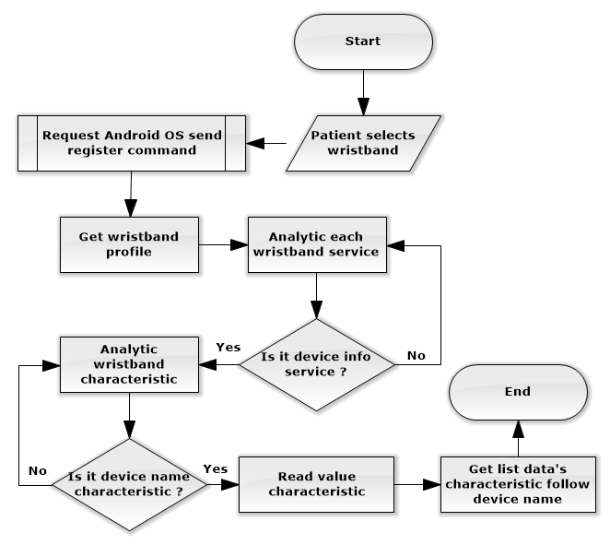

*Figure 9: Algorithms – Connecting Wristband Algorithm - Flow Chart*

### Analytic Meal By Voice.

#### Flow Chart

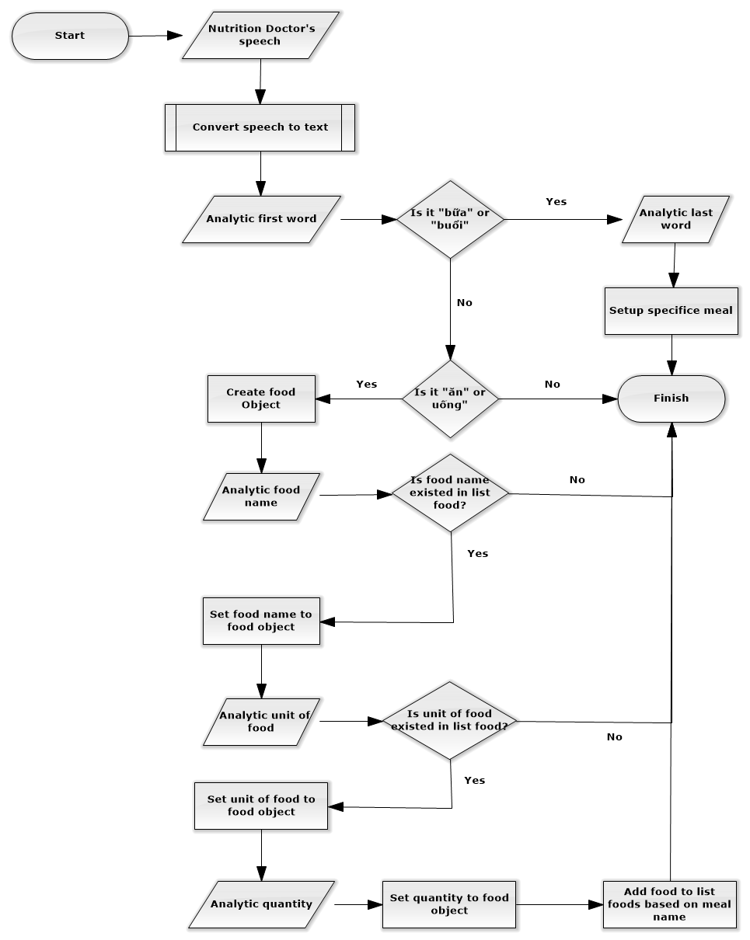

*Figure 10: Algorithms - Analytic Meal By Voice - Flow Chart*

### Mail Scheduler Process

#### Flow Chart

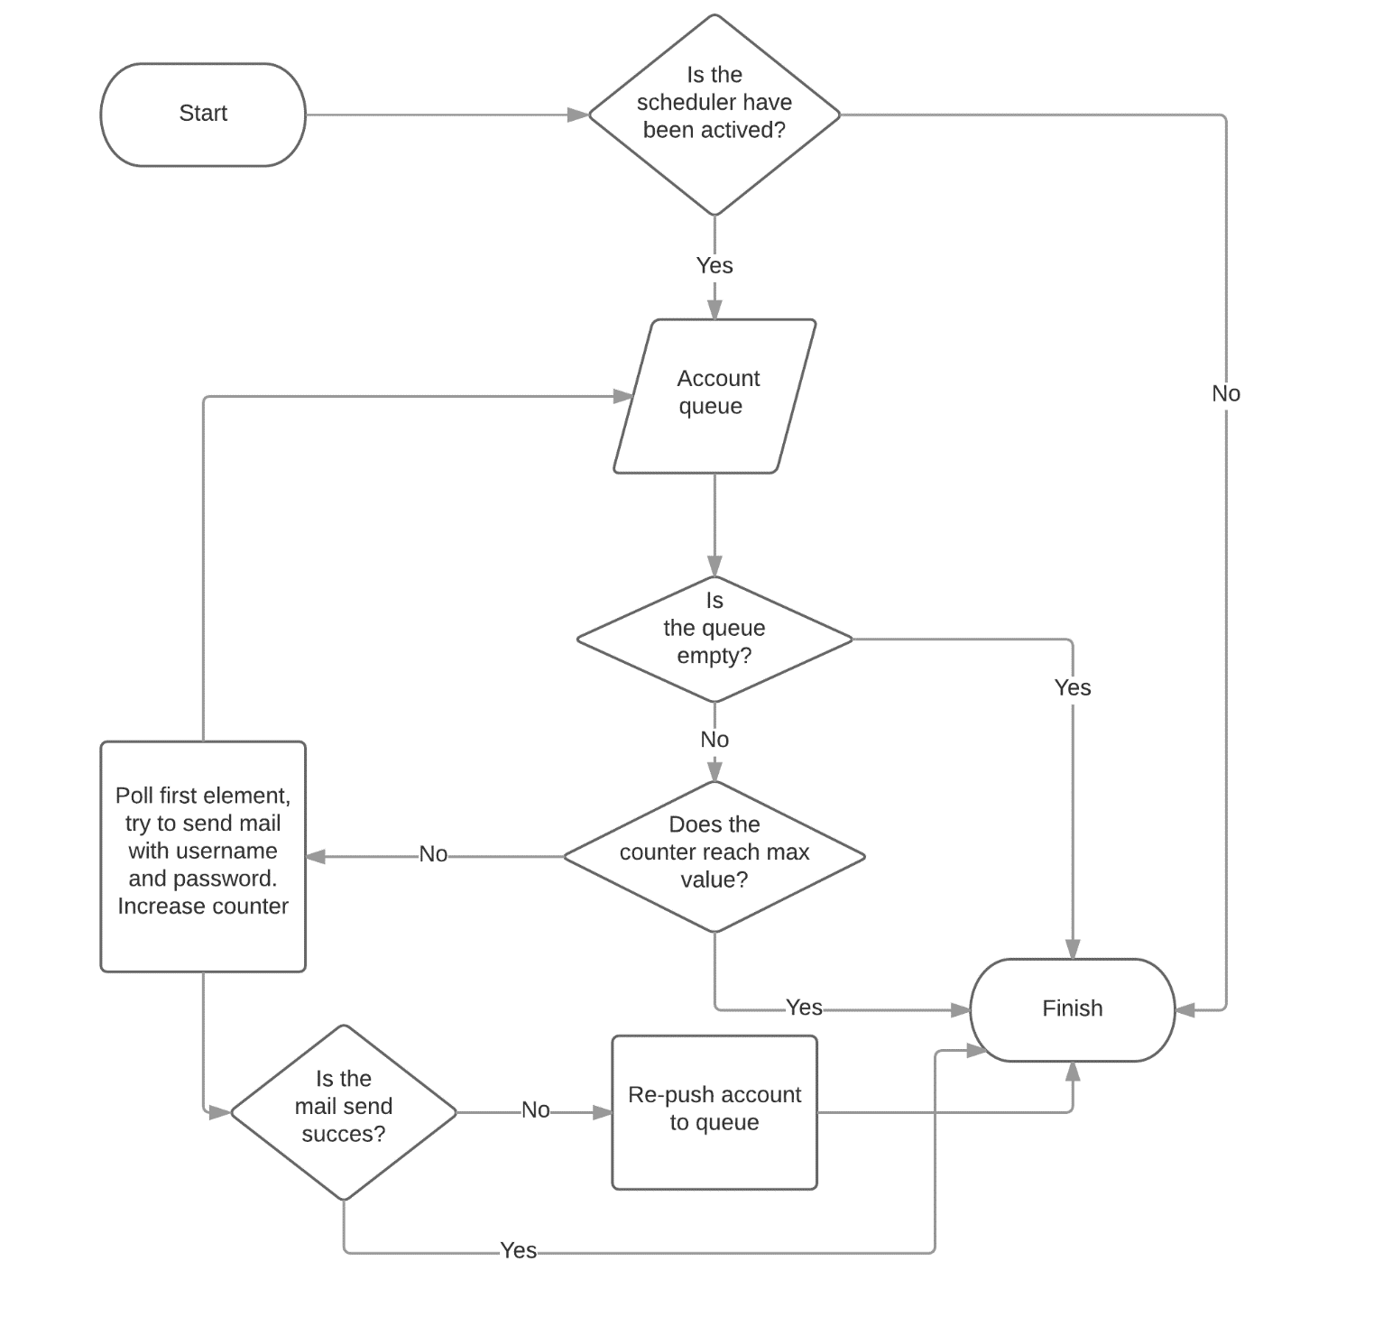

*Figure 11: Algorithms - Mail Scheduler Process - Flow Chart*

### Analytic Medical Record Data Process

#### Flow Chart

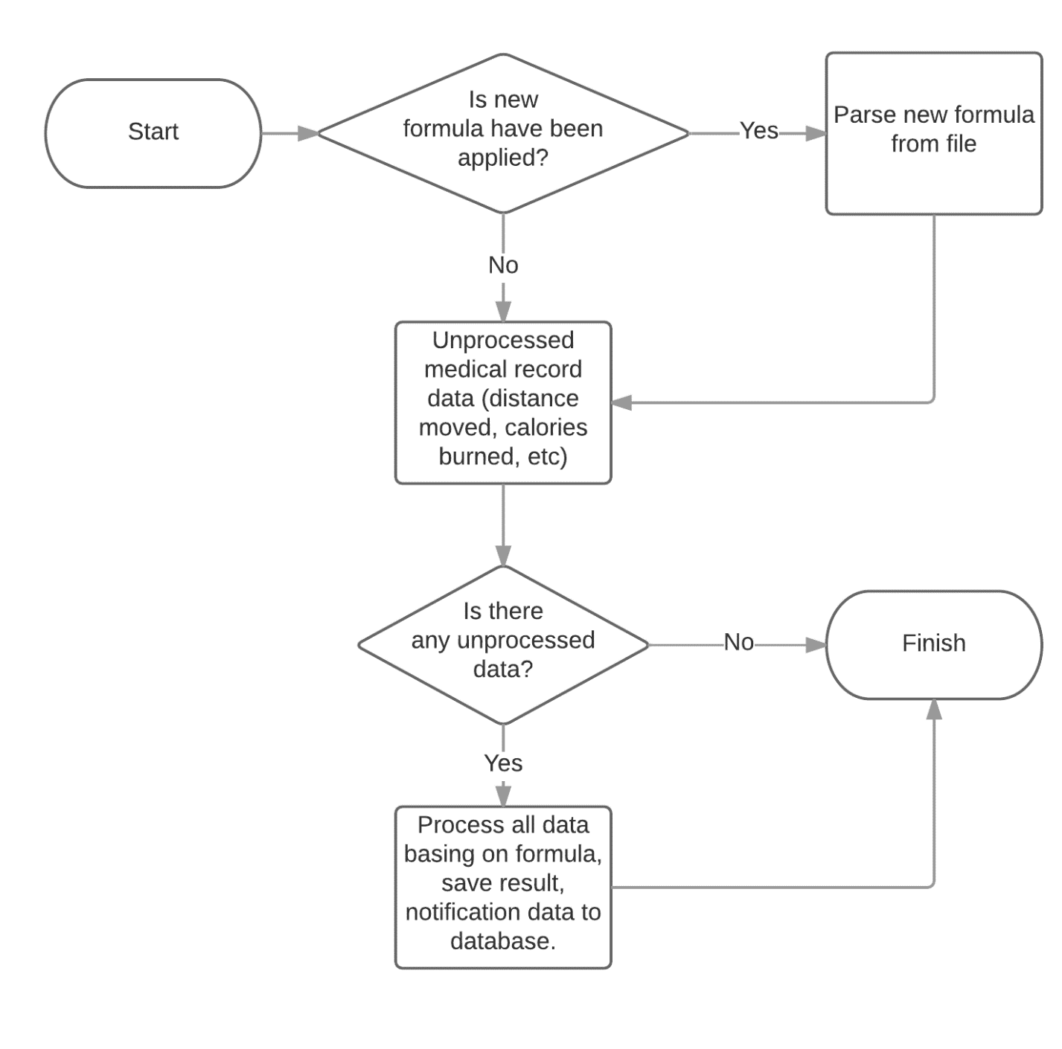

*Figure 12: Algorithms - Analytic Medical Record Data Process - Flow Chart*

### Analytic Treatment From Server

#### Flow Chart

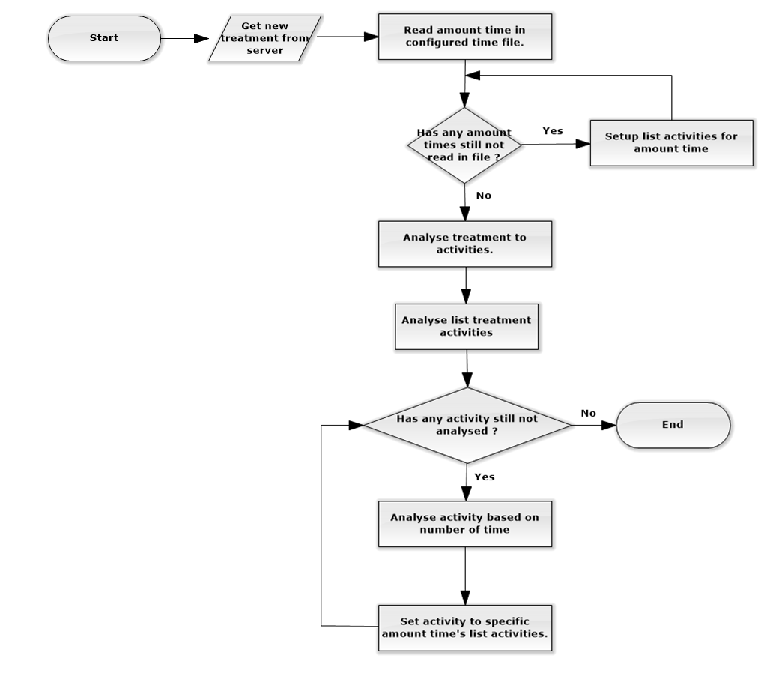

*Figure 13: Algorithms - Analytic Treatment From Server - Flow Chart*

# Appendix

## SOFTWARE ENGINEERING 9th Edition, by Ian Sommerville.

## Code Conventions for the Java TM Programming Language, by Sun Microsystems, rev April 20, 1999.

## Android Developer Guide - Application Fundamentals - *http://developer.android.com/guide/components/fundamentals.html*

## RFC2532 standard for email validation - *https://html.spec.whatwg.org/multipage/forms.html#valid-e-mail-address*

## Characteristics Standard in BLE - *https://developer.bluetooth.org/gatt/characteristics/Pages/CharacteristicsHome.aspx*

## Way to use Bluetooth Low Energy Standard in Android - *https://developer.android.com/guide/topics/connectivity/bluetooth-le.html*

## Formula to calculate distances, calories based on number steps - *http://www.indiacurry.com/weightloss/walkingrunningcalories.htm*

## Standard Fat Regimen - [*http://bacsinoitru.vn/content/benh-beo-phi-1469.html*](http://bacsinoitru.vn/content/benh-beo-phi-1469.html)

## Bảng Thành phần hóa học thức ăn Việt Nam (Viện Dinh Dưỡng Việt Nam) - *http://viendinhduong.vn/home/vi/25/Download.aspx*